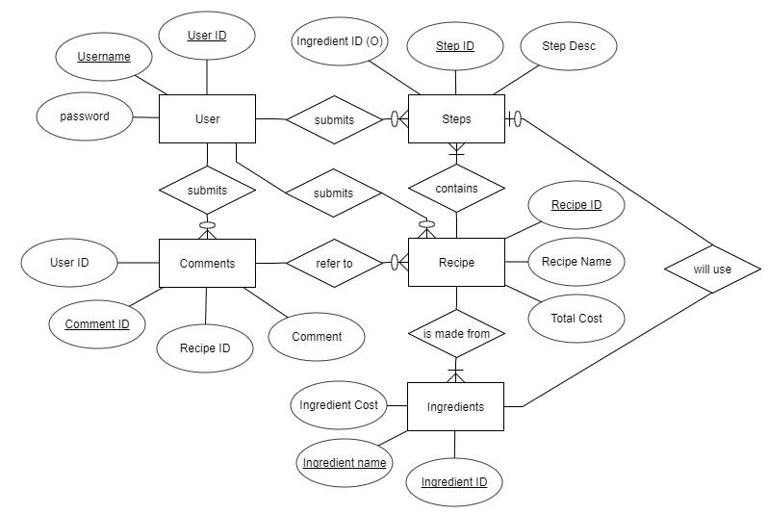

ERD Details:

**User will need attributes:**

Username - unique

Password

User_ID - unique

* Possibly email, so user will have to have unique Email to sign up, will decide later

**Ways user interacts:**

User can submit to the comments

User can submit steps for a recipe

**Comments will need attributes:**

User ID - shared with user

Comment ID - unique

Recipe ID - shared with recipe

Comment

* Possibly rating, depending on how we intend to implement this

**Ways comment interacts:**

Comments are submitted by users

Comments will refer to a recipe

**Recipe will need attributes:**

Recipe ID - unique

Recipe Name

Total Cost

**Ways Recipe interacts:**

Recipes are submitted by user

Recipes contain steps

Recipes contain ingredients

Recipes have comments that refer to them

**Steps will need attributes:**

Ingredient ID - optional, step may not need ingredients

Step ID

Step Desc.

**Ways Steps Interacts:**

User Creates steps

Steps are part of a recipe

Steps use ingredients

**Ingredients will need attributes:**

Ingredient Cost

Ingredient Name

Ingredient ID - unique id

**Ways Ingredients will interact:**

Recipe contains ingredients

Steps may or may not contain ingredients